FACULTY OF COMPUTER SCIENCE AND ENGINEERING

Ghulam Ishaq Khan Institute of Engineering Sciences and Technology, Topi

Lab Duration: 3 hrs. CS311L Operating System Lab Marks: 10

Lab No: 6 Instructor: Ms. Mah Rukh Date: 15-10-2024

**Lab Activity 6**

**Muhammad Bilal 2022360**

**Task 1:**

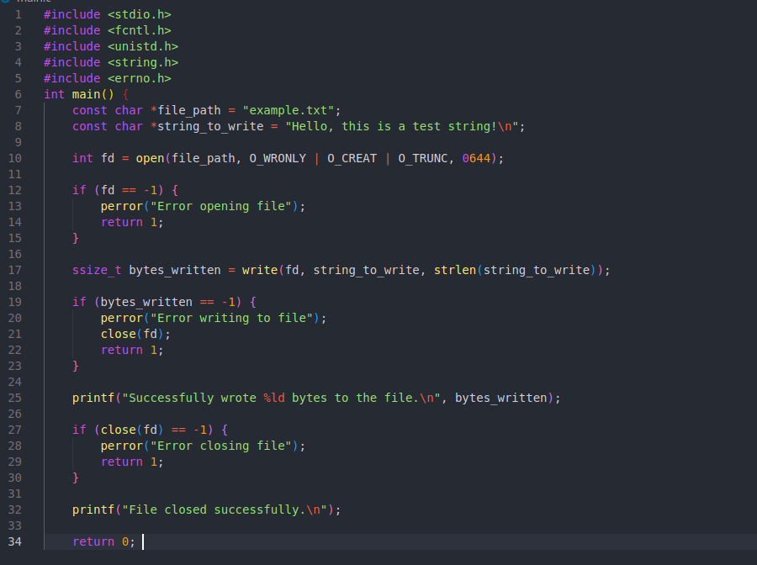

**Task 2:**

**Create a C program that opens a single file using two different file descriptors (both for reading and writing). Write a string using one descriptor and read the contents using the other descriptor, demonstrating the ability to handle multiple file descriptors simultaneously.**

**Task 3:**

**Develop a C program that opens a file, writes multiple lines of text to it, and then utilizes the fseek() function to move the file pointer to different positions (beginning, middle, end). After repositioning the pointer, read and print the contents from the new position to demonstrate effective file pointer management.**



